­

GROUP-12

CSE PROJECT

PRESENTED BY:

CANDIDATES

ELECTION OF

1.BHARGAV SAI ROHITH.T

2.MANOGNA MARNENI

3.ANUSHA KANDULA

**PROJECT TITLE**

**ELECTION OF CANDIDATES**

GROUP MAIL ID’S: [manogna_marneni@srmap.edu.in](mailto:manogna_marneni@srmap.edu.in)

[anusha_kandula@srmap.edu.in](mailto:anusha_kandula@srmap.edu.in)

[bhargavsai_t@srmap.edu.in](mailto:bhargavsai_t@srmap.edu.in)

* AIM: To provide a computer-based application for casting of votes which enables users to find the result in short amount of time as the time invested in counting of votes is saved. The names of candidates participating in the election will displayed so it is easy for users to make comparison among candidates and select the candidate of their choice. The winner of the elections conducted is announced in no time
* ABSTRACT: Election of candidates: As the name indicates, it is used in elections to cast vote and used to calculate the vote counting and declares the winner of elections. Election of candidates is a software application developed for the purpose of conducting elections according to the necessity. The application works on any windows/android devices. It mainly focuses at casting, counting of votes and declaring the leading candidate according to the votes casted.
* TECHNOLOGY USED: This project is done by using the following technologies:

1 Ubuntu

2.online c complier

* SAMPLE SCENARIO: Traditionally, people use ballot boxes and papers for casting votes. After casting of votes the counting of votes is done by humans which takes a lot of time waste and sometimes wrong counting may also takes place. Having Elections of candidate’s code, we can over cross all these problems and it is helpful in making all these aspects easier. After execution of the code, it shows the options like 1. casting of votes,2. find vote counting 3. find leading candidate and 0. exit. The end user may choose their respective option according to their situation. After choosing options, our code allows to cast vote if the end user choose press 1. casting of votes. If the end user chooses 2. find vote counting, the votes for the respective candidates will be seen on the screen. If the end user chooses 3. find leading candidate the winner is of the elections is seen on the screen. And finally, for exiting of elections the end user has to press 0. Thus, election of candidates is helpful in doing all the processes easier and also saving the valuable time of end-user.
* ASSUMPTIONS TAKEN: In this program we are assuming 4 members as the candidates in the election. In this program, the we are giving the input as votes (vote casting). And we are expecting the output as vote counting and declaration of leading of candidate. And the concepts used here are few pre-processor directives, functions, if- else if statements, while statements, switch cases to complete our code and execution of our program. The user should have the appropriate version of windows and any type of operating system. And 2GB RAM is the minimum requirement for this project. And this project doesn't require any additional software.
* DETAILS HANDLED: The input taken is votes casting of end-users. The following conditions are checked: If the votes for 1stcandidate is greater than 2nd and 3rd and 4th candidates then print the leading candidate as candidate 1. If the votes for 2nd candidate is greater than 3rd and 4th and1st candidates then print the leading candidate as candidate 2. If the votes for 3rd candidate is greater than 4th and 1st and 2nd candidates then print the leading candidate as candidate3.If the votes for 4thcandidate is greater than 1st and 2nd and 3rd candidates then print the leading candidate as candidate4. Except these situations the code shows no winning chances for all the candidates, according to votes obtained.
* SAMPLE INPUT AND OUTPUT: The input given to the program is votes (vote casting). The output given from the code is vote counting and declaration of leading candidate.

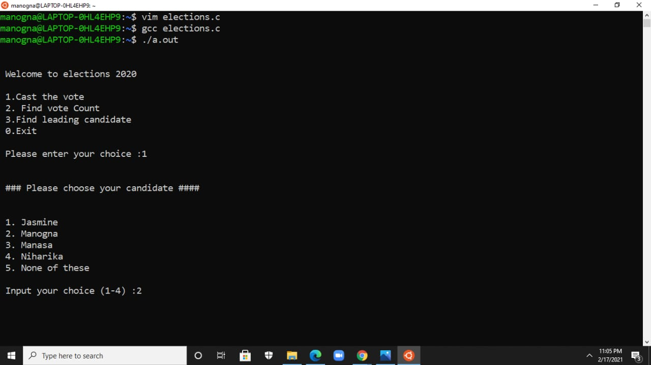

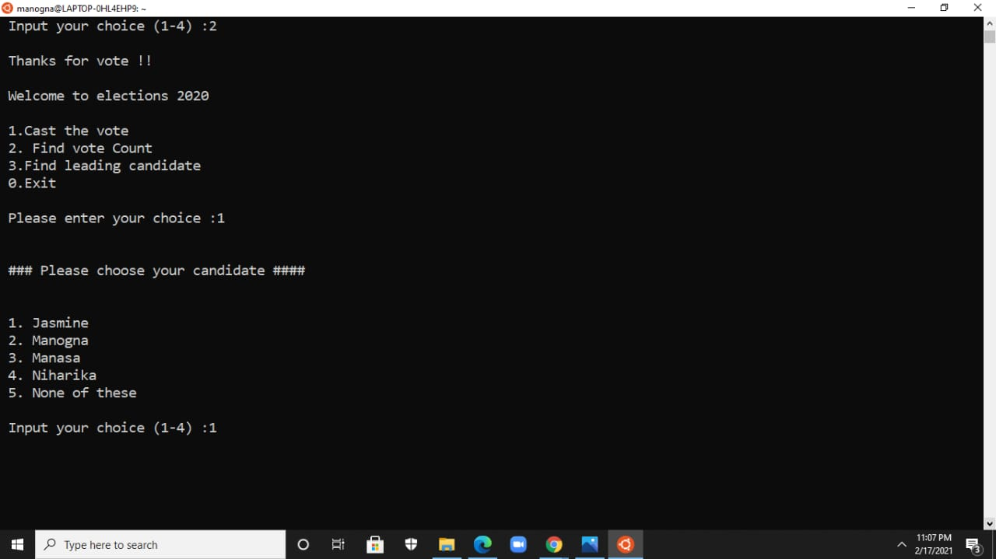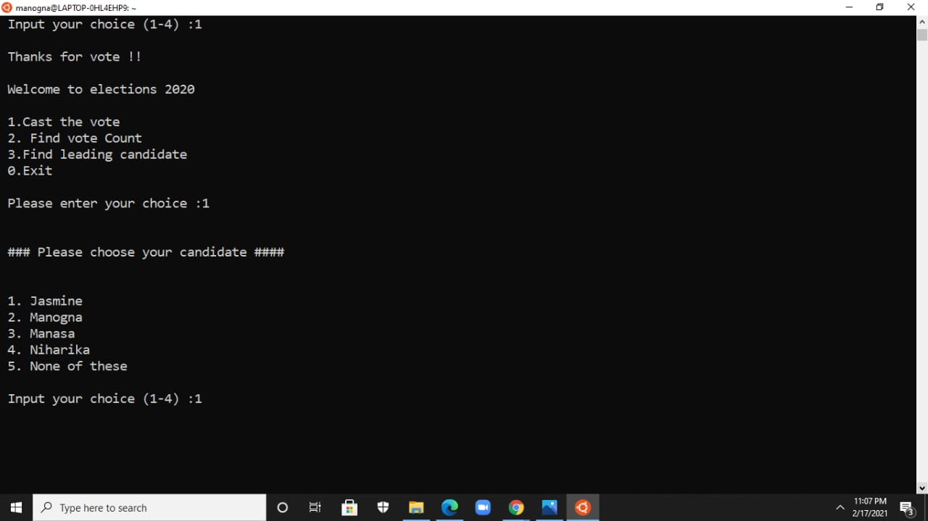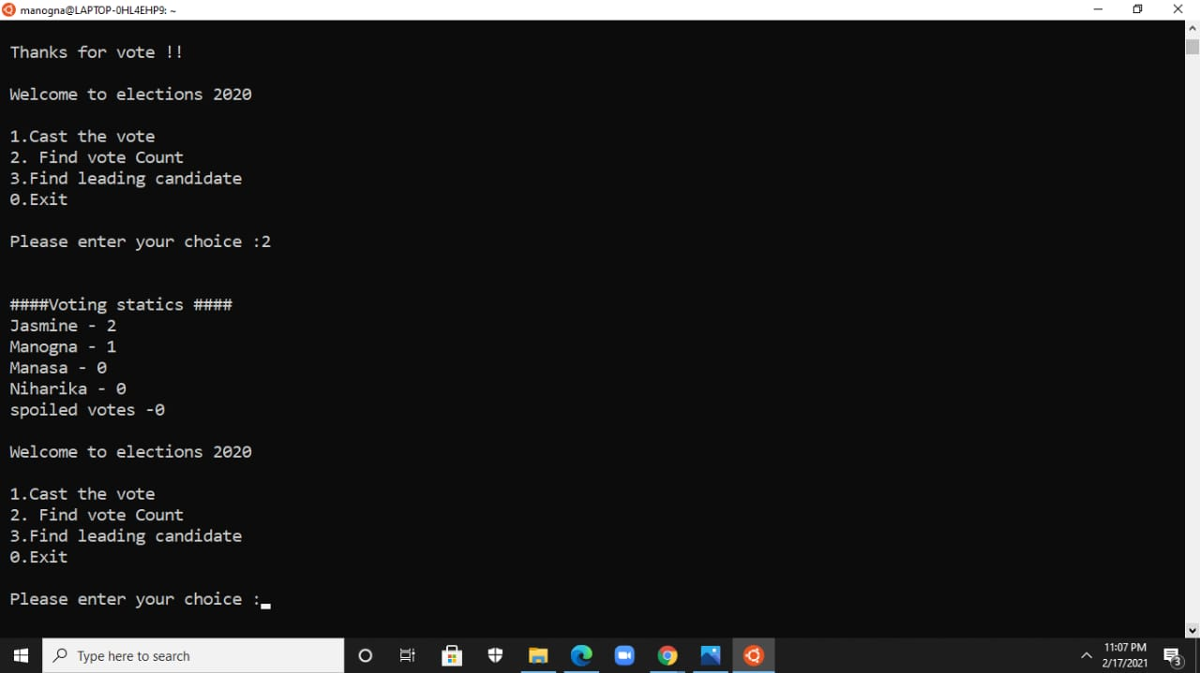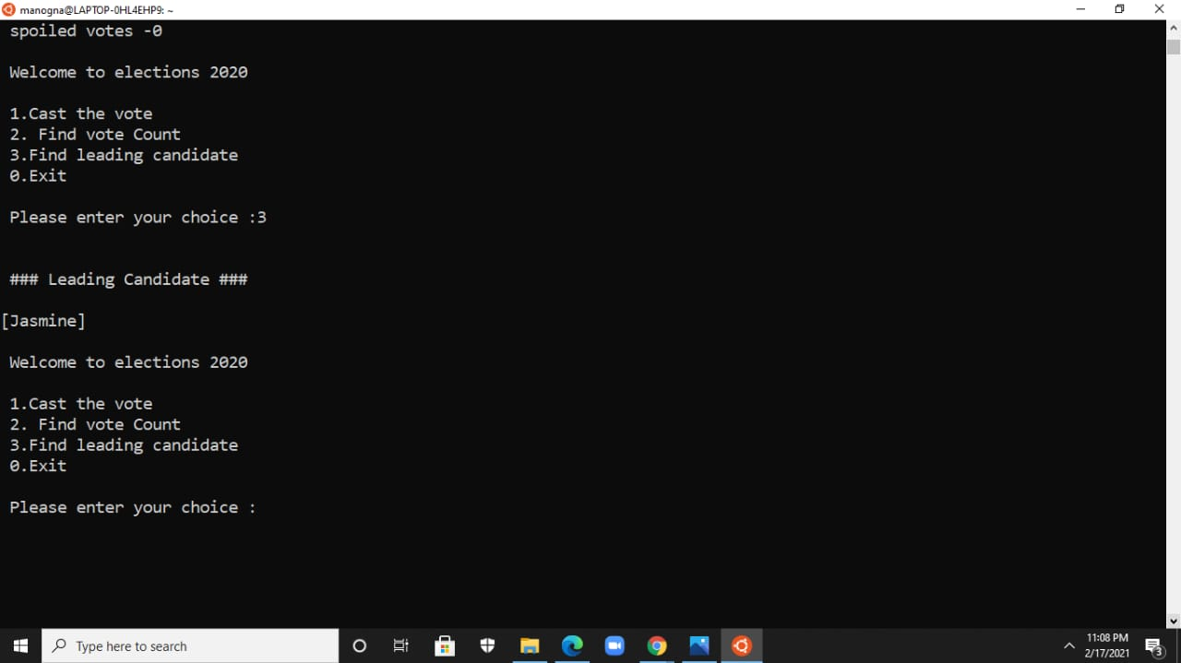

ALGORITHM:

STEP1: Start

• STEP2: End user is allowed to see the following statements

• Welcome to elections

1. cast the vote

2. find the vote

3. find the leading candidate

4. exit

• Step3: end-user has to press their choice. Like1 for casting of votes

• If 1 pressed and the end –user used has to see the available candidates who stand on elections.

• Step4: End user to see ‘please choose your candidate”

1. candidate1

2. candidate2

3. candidate3

4. candidate4

5. none

• End user has to choose their candidate whom he wants to vote.

• Step5: if end user wants to vote press numbers given according to the candidates in case, if the end-user press any number other candidates ‘numbers. u will see wrong choice please retry.

• step6: all the end users have to follow this process until the casting of votes get completed

• step7: then the program again shows step 2 and if end user press 2 for vote counting.

• step8: the votes got by respective candidates is displayed

• step9: the program again shows step 2 and the end user has to press 3 for finding the leading candidate.

• step10: the end user is allowed to see the leading candidate or the winner of the elections.

• step11: after the completion of elections press 0 to exit.

• step12: stop.

* END USER: Election of candidates allow the voters who are 18 and above 18 as their age. not only that and who belongs to our country is also had to take into regard we say that the end-users are the people who belongs to our country and has their voter cards and any identification card like Aadhaar/white card and their age must be 18 and above are considered as the end users of this.
* CONCLUSION: Election of candidates is the project which are used to conduct the elections in proper way without any errors and expenditure for conducting the elections also get reduced by our program and our program gives results without any errors

In democratic country people have right to choose their own leader and this process helps them to find a good leader who can pave the right path.

**ROLL NUMBERS:**

**BHARGAV SAI ROHITH-AP20110010529**

**ANUSHA KANDULA -AP20110010562**

**MANOGNA MARNENI -AP20110010542**

- THE END -